QPFL Hall of Fame

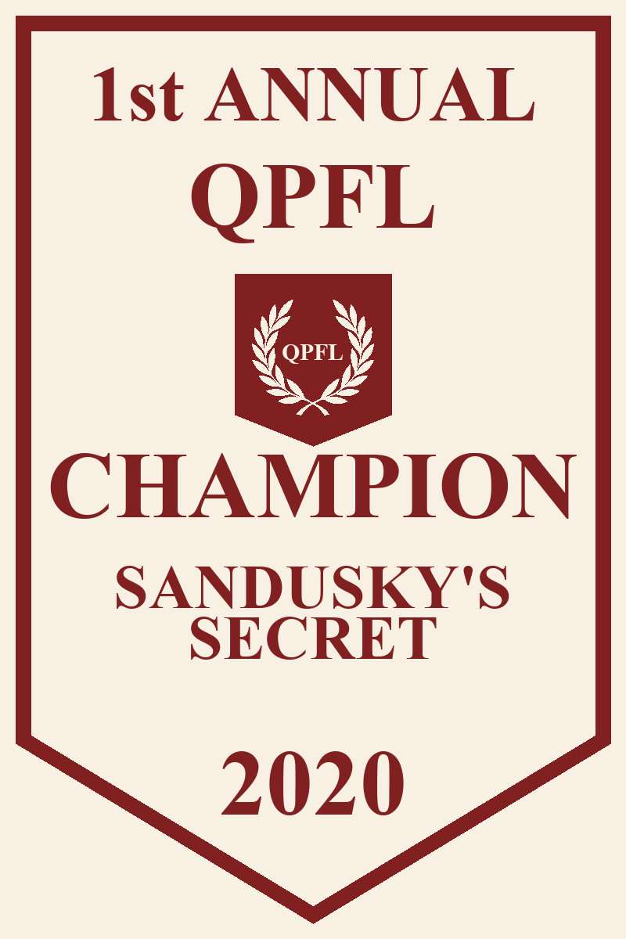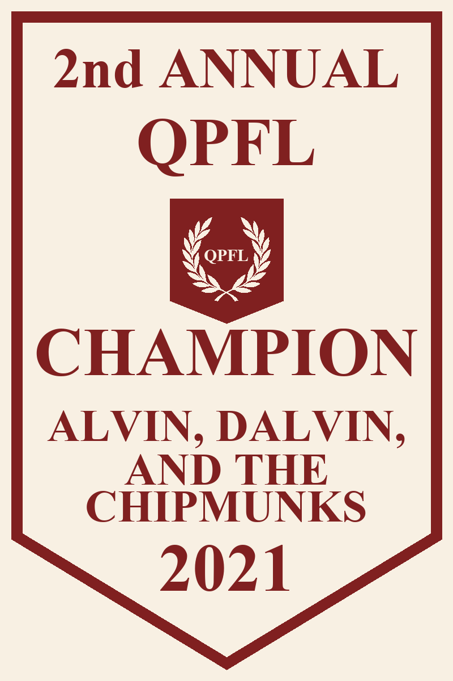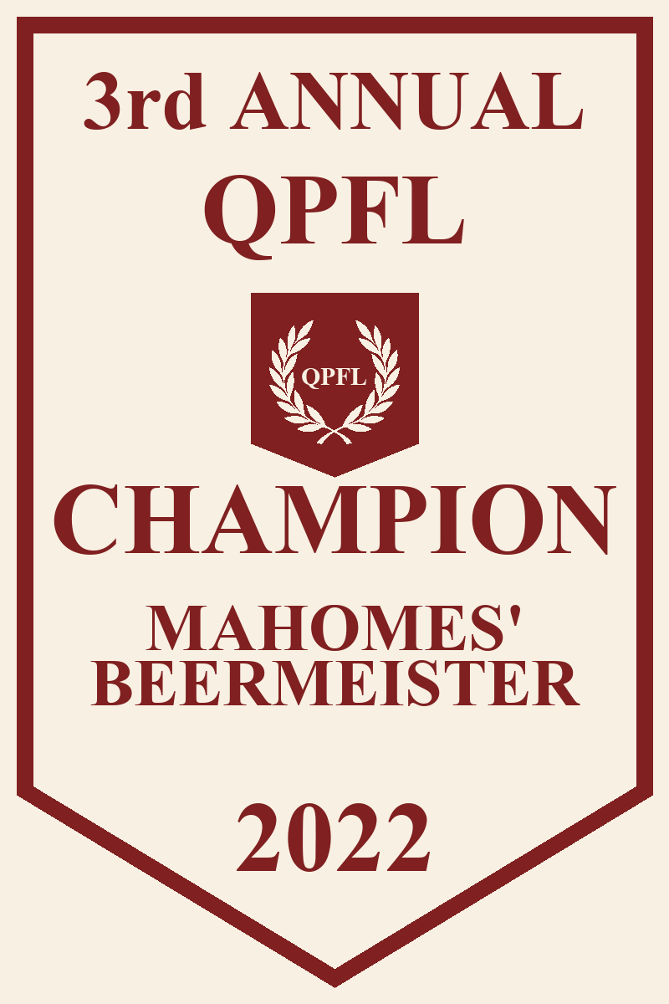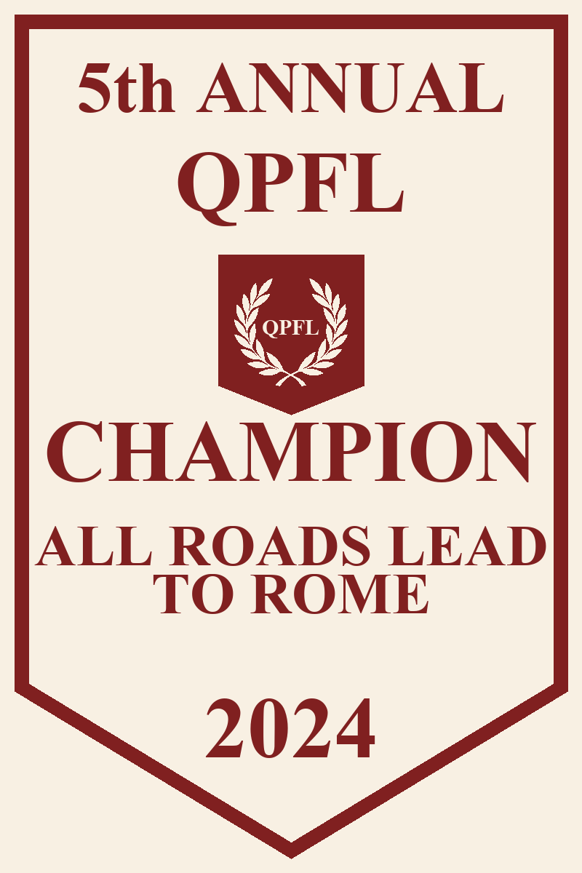

QPFL Summary

Owner | Seasons | Record | Last Place | Toilet Tourney Berths | Playoff Berths | 3rd Place | 2nd Place | Rings
Griff | 5 | 51-21-1 | 0 | 0 | 5 | 0 | 1 | 3
Kaminska | 5 | 45-25-3 | 0 | 0 | 4 | 1 | 3 | 0
Reardon | 5 | 38-35-0 | 0 | 2 | 2 | 1 | 0 | 1
Arnav | 5 | 33-38-2 | 1 | 2 | 1 | 0 | 0 | 0
Joe W. | 5 | 33-40-0 | 1 | 1 | 1 | 1 | 0 | 0
Bill | 5 | 26-47-0 | 1 | 3 | 0 | 0 | 0 | 0
Stephen | 4 | 34-25-0 | 0 | 1 | 3 | 1 | 0 | 0
Spencer | 4 | 25-33-1 | 1 | 1 | 2 | 0 | 0 | 1
Ryan | 3 | 25-32-2 | 0 | 2 | 1 | 0 | 1 | 0
Tim | 3 | 19-26-0 | 1 | 1 | 2 | 0 | 0 | 1
Joe K. | 3 | 23-21-0 | 0 | 0 | 1 | 1 | 0 | 0
Bocki | 2 | 11-17-0 | 0 | - | 1 | 0 | 0 | 0
Anagh | 1 | 7-8-0 | 0 | 1 | 0 | 0 | 0 | 0
Miles | 1 | 4-10-0 | 1 | - | 0 | 0 | 0 | 0

QPFL Finishes by Year

2025

TBD
- TBD
- TBD
Toilet Bowl - TBD
Rivalry Week Winner - Joe/Joe

2024
- Griffin Ansel
- Redacted Kaminska
- Stephen Schmidt
Toilet Bowl - Ryan (Arnav, Anagh, Bill)
Rivalry Week Winner - Connor

2023
- Spencer/Tim
- Connor Kaminska
- Censored Ward
Toilet Bowl - Arnav Patel (Bill, Stephen, Redacted Reardon)
Rivalry Week Winner - Griff

2022
- Griffin Ansel
- Redacted Kaminska
- Joe Kuhl
Toilet Bowl - Tim/Spencer (Bill, Ryan, Connor)
Rivalry Week Winner - Griff

2021
- Griffin Ansel
- Ryan Ansel
- Connor Reardon & Stephen Schmidt
Jambo - Redacted Kaminska
Loser: Joe Ward

2020
- Connor Reardon
- Griffin Ansel
- Redacted Kaminska
Jambo - Miles Agus
Loser: Miles Agus

QPFL MVPs
2024 - Saquon Barkley (GSA)
2023 - Amon-Ra St. Brown (S/T)
2022 - Travis Kelce (CGK)
2021 - Jonathan Taylor (CWR/SLS)
2020 - Derrick Henry (RCP)

Team Records

Single Game Records

Most Points Scored
- Bocki Balboa (RCP) - 156 (Week 5, 2021)
- Football Team (GSA) - 152 (Week 8, 2020)
- War Crimes for Reagan (RCP) - 151 (Week 12, 2020)

Least Points Scored
- Suspended for Inactivity (JRW) - 18 (Week 10, 2021)
- The One Percenters (WJK) - 20 (Week 10, 2021)
- Fantasy Football with Chinese Characteristics (WJK) - 28 (Week 12, 2023)

Largest Margin of Victory

Mahomes’ Beermeister (GSA) over Canseco’s Pharmacist (RPA) - 131 (Rivalry Week 5, 2022)

War Crimes for Reagan (RCP) over Suspended for Inactivity (JRW) - 115 (Week 12, 2020)

Alvin, Dalvin, and the Chipmunks (GSA) over Suspended for Inactivity (JRW) - 99 (Week 10, 2021)

TuAnon (GSA) over Canseco’s Pharmacist (RPA) - 95 (Rivalry Week 5, 2023)

Montez Sweat Drippin Down my Balls (CWR) over Josh Allen’s Deleted Tweets (CGK) - 94 (Rivalry Week 5, 2024)

Player Records

Single Game Records

Most points scored
- Josh Allen (CGK) - 57 (Week 14, 2024)
- Tom Brady (RCP) - 55 (Week 5, 2021)
- Alvin Kamara (CGK) - 52 (Semi-Finals, 2020)

Least points scored, offensive player
- QB Spencer Rattler (CWR) - -2 (Week 8, 2025)
- WR Zay Flowers (CGK) - -2 (Week 12, 2025)
- RB Brian Robinson Jr. (RPA) - -1 (Toilet Bowl Semi-Finals, 2024)
- RB Bijan Robinson (CWR) - -1 (Week 15, 2023)
- TE T.J. Hockenson (AYP) - -1 (Toilet Bowl Semi-Finals, 2020)

Least points scored, Kickers
- K Matt Prater (GSA) - -3 (Championship Week, 2021)
- K Tyler Bass (WJK) - -3 (Week 11, 2021)
- K Nick Folk (WJK) - -2 (Semi-Finals 2022)
- K Younghoe Koo (AYP) - -2 (Week 11, 2021)
- K Jake Elliott (GSA) - -2 (Week 6, 2020)

Defensive Hall of Shame
- Denver Broncos (WJK) - -6 (Week 10, 2020)
- Buffalo Bills (JRW) - -6 (Week 11, 2021)
- Los Angeles Chargers (JK) - -6 (Week 3, 2022)
- Denver Broncos (SLS) - -6 (Semi-Finals, 2022)
- Jacksonville Jaguars (CWR) - -6 (Week 4, 2023)
- Washington Commanders (JRW) - -6 (Week 13, 2023)
- Cleveland Browns (AYP) - -6 (Week 13, 2023)
- Dallas Cowboys (S/T) - -6 (Championship Week, 2024)
- Chicago Bears (CGK) - -6 (Week 2, 2025)
- Baltimore Ravens (AYP) - -6 (Week 3, 2025)

Most points scored, non QB
- Alvin Kamara (CGK) - 52 (Semi-Finals, 2020)
- Joe Mixon (CGK) - 50 (Week 9, 2022)
- Jonathan Taylor (CWR/SLS) - 49 (Week 11, 2021)

